Format of Question paper for Midsemester Examination

Birla Institute of Technology & Science, Pilani
Work Integrated Learning Programmes Division
First Semester 2024-2025

Regular Examination
(EC-2 Regular)

Course No. : AIMLCL ZG513
Course Title : Advanced Deep Learning
Nature of Exam : Closed Book
Weightage : 30%
No. of Pages = 3

No. of Questions = 3
Duration :
Date of Exam :
Note to Students:
- Please follow all the Instructions to Candidates given on the cover page of the answer book.
- All parts of a question should be answered consecutively. Each answer should start from a fresh page.
- Assumptions made if any, should be stated clearly at the beginning of your answer.

Q.1. [1+2+1+1+2+3=10 Marks]

- A 2x2 image is given by

I= [25 60
10 30]
A convolution kernel is given by

F= [1 0 -1
1 0 -1
1 0 -1].

- What will be the size of feature map obtained by transposed convolution with valid padding and stride 2?
5x5
- What will be the values of the feature map?

25 0 -25 0 0 0 0 60 0 -60 0 0 0 0 0 0 0 0 0 0 25 0 35 0 -60
25 0 -25 0 0 0 0 60 0 -60 0 0 0 0 0 0 0 0 0 0 25 0 35 0 -60
25 0 -25 0 0 + 0 0 60 0 -60 + 10 0 -10 0 0 + 0 0 30 0 -30 = 35 0 55 0 -90
0 0 0 0 0 0 0 0 0 0 10 0 -10 0 0 0 0 30 0 -30 10 0 20 0 -30
0 0 0 0 0 0 0 0 0 0 10 0 -10 0 0 0 0 30 0 -30 10 0 20 0 -30

- Consider a fully connected autoencoder (each hidden node is connected to all inputs and all outputs) with two dimensional binary input and one hidden layer with sigmoid activation function.

At iteration t, the weights are shown in the following autoencoder architecture along with the input vector (x1=1, x2=0). All bias values are zero. Assume learning rate = 0.25 and momentum constant = 0.75. Also assume at t-1, w1= -0.5, w2=0.5, w3=0.5 and w4= -0.5.

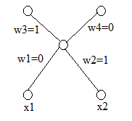
- What activation function will you choose at the output node? Sigmoid
- What loss function will you choose for training this autoencoder?
Sum of binary cross entropy over output nodes
- What will be the value of loss function at iteration t?
Output=(1/(1+exp(-0.5), 0.5)=(0.62,0.5)
Loss function value=-1*ln(0.62)-1*ln(0.5)=1.165
- What will be the weights w1 and w3 in iteration t+1 assuming backpropagation with ordinary gradient descent is used?
w3=1-0.25*(0.62-1)*0.5
w1=0-0.25*(0.62-1)*1*0.5*(1-0.5)*1

Q.2. [2.5+2.5=5 marks]
Recall, Laplace distribution is given by
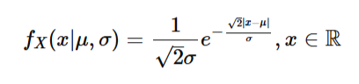
If data instances {-2, -1, 0, 2, 3} are obtained via sampling the above distribution, find the maximum likelihood estimate of (μ, σ).

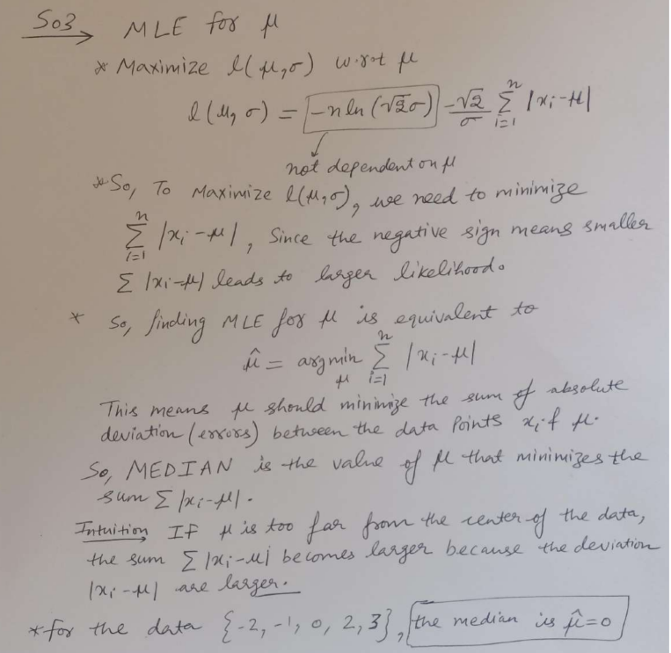
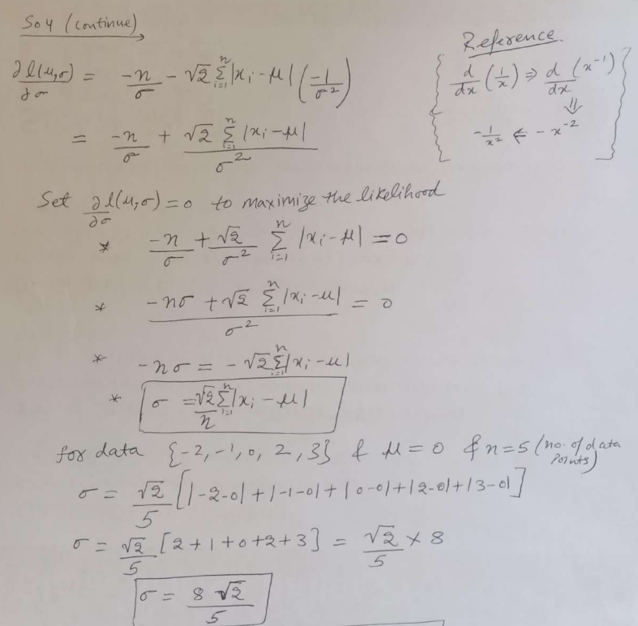

Q.3. 5 marks

Consider a single hidden layer autoencoder where the input is a 1-D random variable X, the hidden state (output) is a 1-D variable Z and the output is a 1-D variable Y. Let the weight on the link between X and Z be α, and the weight on the link between Z and Y be β. Assume that all neurons involved use identity (linear) activation functions and a bias of 0. X is sampled randomly from uniform distributed between -2 and 2. What values of α and β will minimize the expected value of loss function if we use square error as loss function together with L² regularization functional λ(α² + β²) with parameter λ = 0.5. Show all steps clearly.

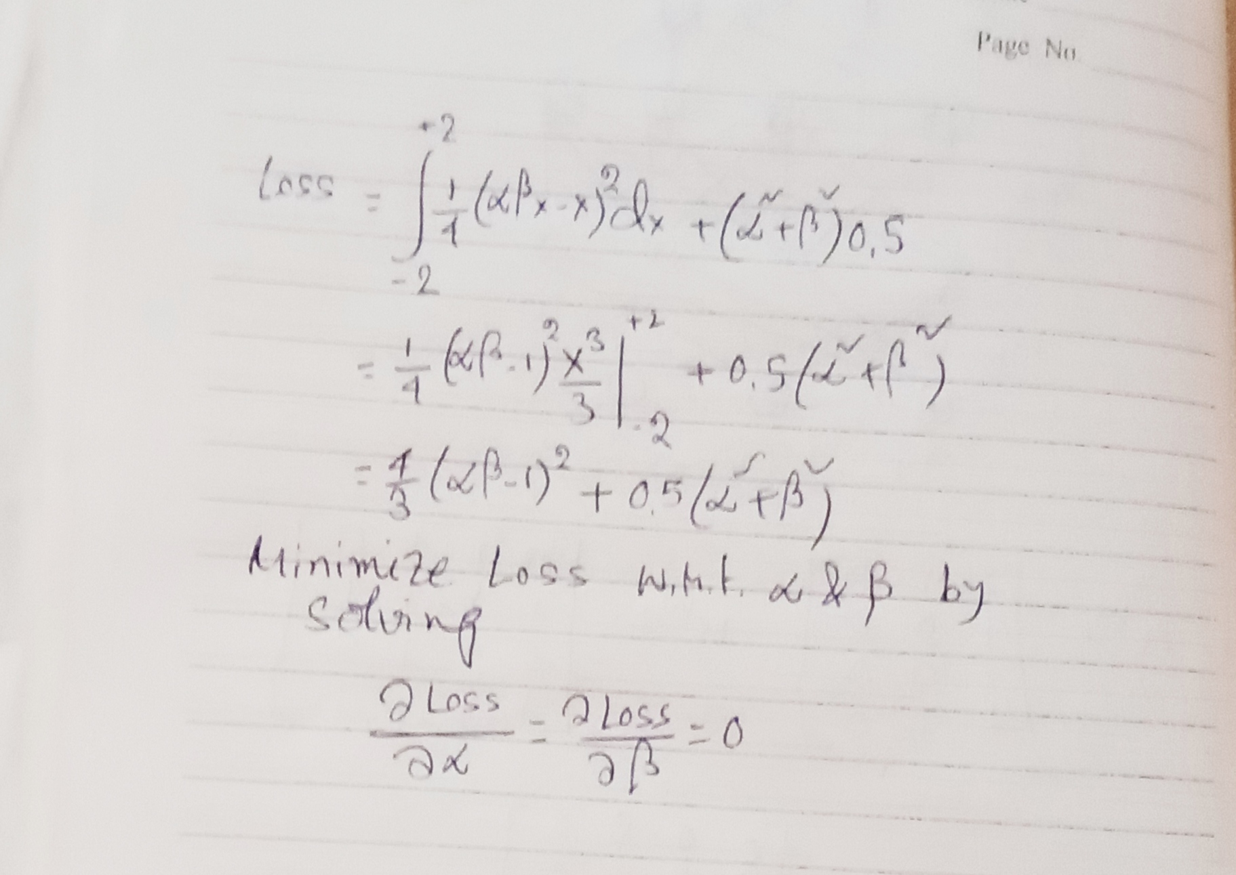

α = β = (1-3/8)^{0.5} = +/- 0.7905

Q.4. [6+4=10 Marks]
A. Assume the following MADE is used to calculate p(x₁), p(x₂|x1), p(x₃|x₂, x₁). x_{t} is the data value at time t and x1 arrives first and so on as shown on the figure. All node numbering is given. Design all the necessary masks and show the final connections. Show all steps.
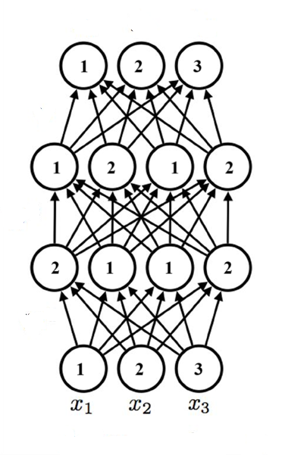
- What advantages PixelCNN++ offers over standard PixelCNN or Gated PixelCNN? Why gated PixelCNN is preferred over PixelCNN? What are two disadvantages of incremental PCA?

